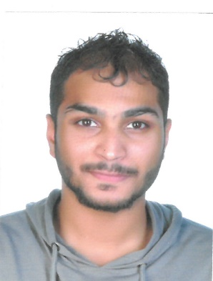

**CURRICULUM VITAE**

**ALI HUSAIN ABDULLA AHMED MAKI ALASFOOR**

Manama, Kingdom of Bahrain

Contact : +973 38705316

Email : aasfoor16@gmail.com

|  |  |
| --- | --- |
|  | |
| ***Professional Objective:*** |

To strive for a challenging job in a progressive organization, where I can contribute and build my professional career along with the growth of organization and to give the best of my qualification, experience and abilities.

|  |
| --- |
| ***Personal Information:*** |

Citizenship : Bahrain

Sex : Male

Marital Status : Single

Date of Birth : 13/07/1996

CPR No : 960703420

Languages Known : Arabic & English

|  |
| --- |
| ***Educational Qualifications:*** |

* Jidhafs Secondary school

|  |
| --- |
| ***Skills*** |

* Computer Literate / Typing / Encoding Operating and adding Machine

|  |
| --- |
| ***Personal Strength:*** |

* Energetic
* Co-operative and conscientious
* Quick learner
* Hard worker

|  |
| --- |
| ***Declaration:*** |

I hereby declare that the above mentioned are true to the best of my knowledge and Belief.

**ALI HUSAIN ABDULLA AHMED MAKI ALASFOOR**